For the given JSON iterate over all for loop:

var json = [{
"id" : "222008747",
"msg" : "Hii",
"task" : "xxx",
"mail": "abc@gmail.com"
},
{
"id" : "222008748",
"msg" : "Hello",
"task" : "yyy",
"mail": "efg@gmail.com"
}];

//for loop
for(var i = 0; i < json.length; i++) {
var obj = json[i];

console.log(obj.id);
console.log(obj.msg);
console.log(obj.task);
console.log(obj.mail);
}

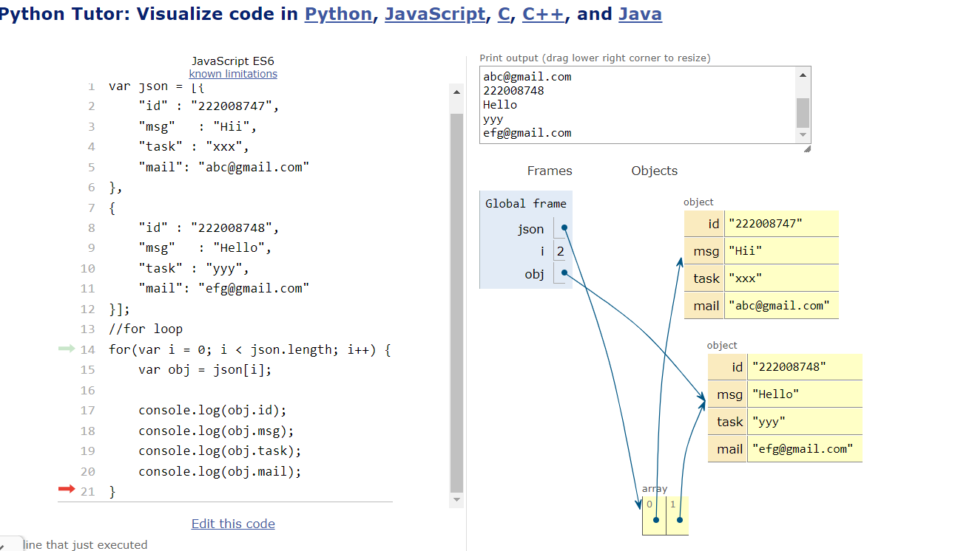

//for Each
json.forEach(function(obj) { console.log(obj.msg); });

//for In
for (var key in json) {
if (json.hasOwnProperty(key)) {
console.log(json[key].id);
//console.log(json[key].msg);

}
}

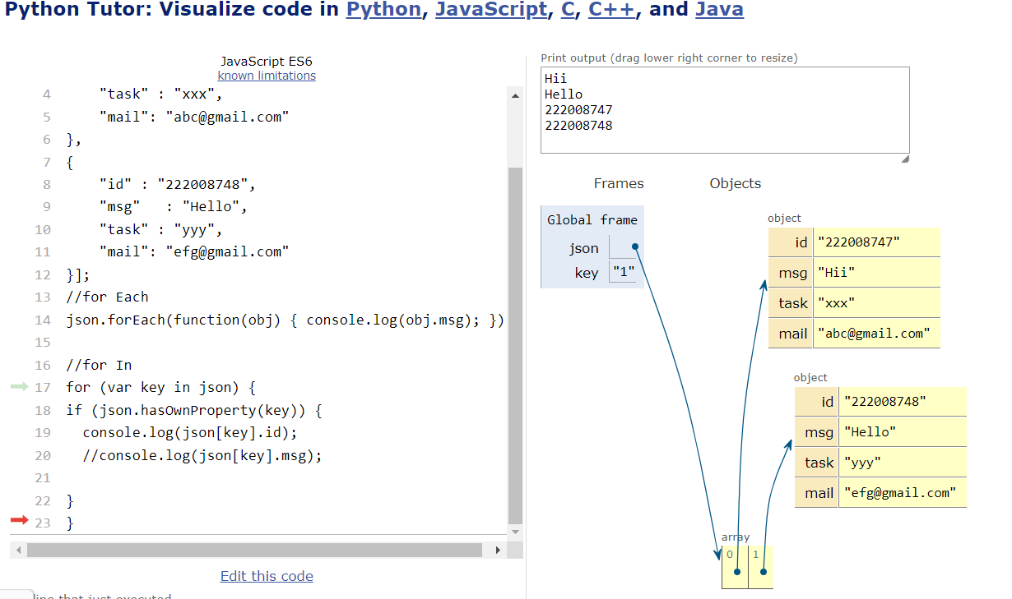

//for Each
json.forEach(function(obj) { console.log(obj.msg); });

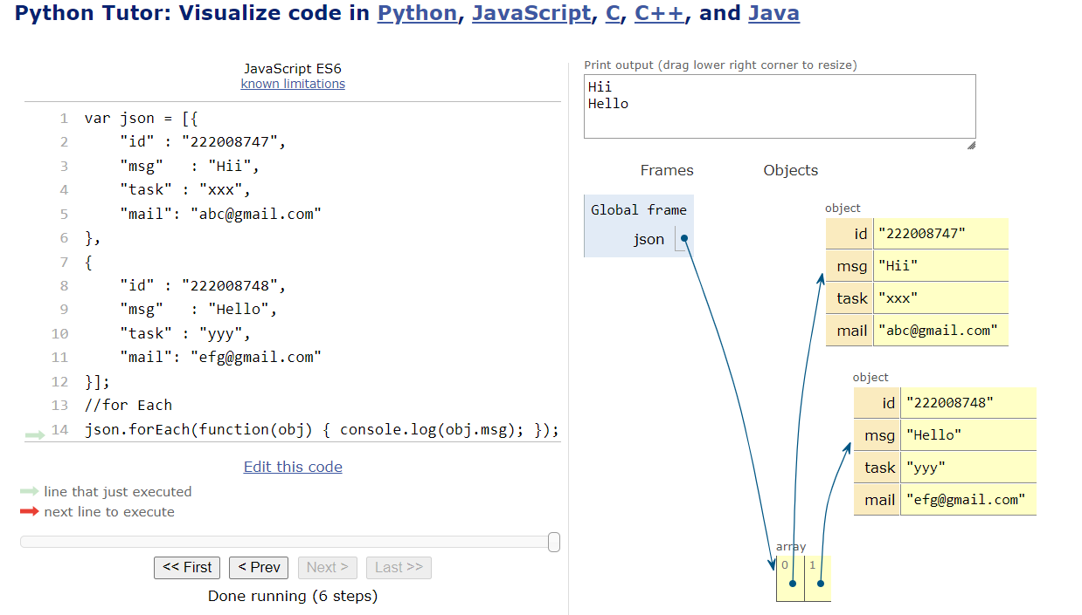

//for In
for (var key in json) {
if (json.hasOwnProperty(key)) {
console.log(json[key].id);
}
}
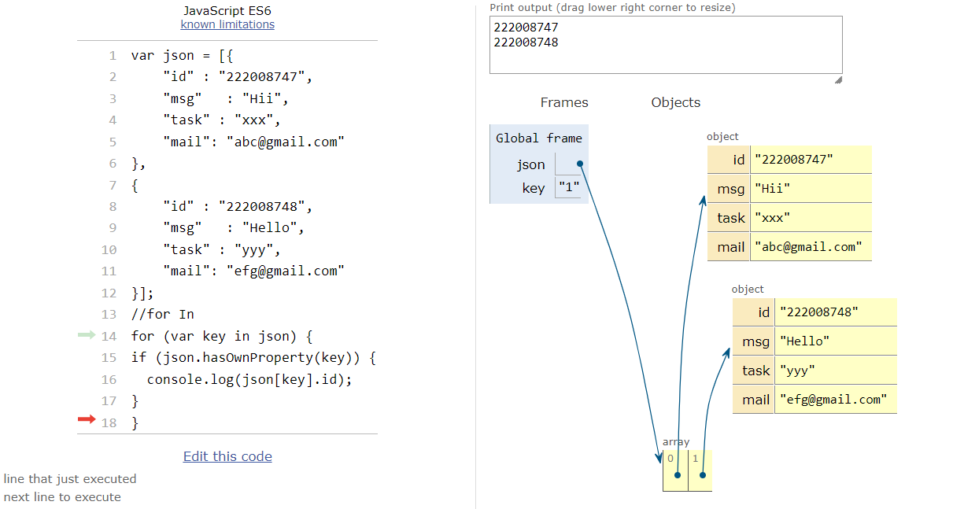

//for Of
let text = "";
for (let x of json[key].id) {
text += x;
}
console.log(text);

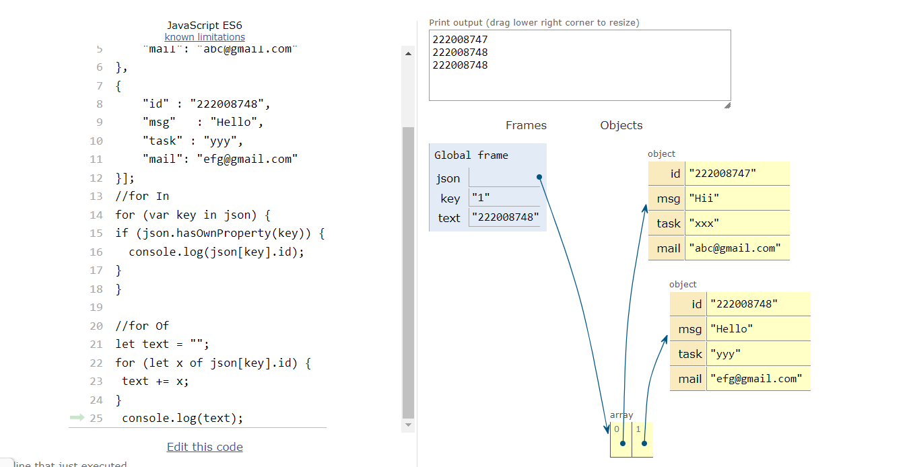

2.Create your own resume data in JOSN format:
{
"basics": {
"name": "Your first and last name",
"label": "",
"picture": "",
"email": "Your email address",
"phone": "A phone number, with any formatting you like. E.g. (555) 555-5555.",
"degree": "",
"website": "Your website URL",
"summary": "A one-sentence to one-paragraph overview text. Do not include any line-breaks.",
"location": {
"address": "Your street address or mailing address",
"postalCode": "Your postal code (ZIP in the U.S.)",
"city": "Your city",
"countryCode": "Your country (e.g. USA)",
"region": "Your region (state in the U.S.)"
},
"profiles": [
{
"network": "A social media or other profile that you would like to include (e.g. LinkedIn, Twitter)",
"username": "Your username on this network",
"url": "A URL to your user profile page"
}
]
},
"work": [
{
"company": "Your employer name",
"position": "Your job title",
"website": "The URL for the employer's website",
"startDate": "Your start date, in YYYY-MM-DD format",
"endDate": "Your end date, in YYY-MM-DD format (leave blank for a current position)",
"summary": "A one-sentence to one-paragraph summary of this employer or position",
"highlights": [
"Bullet-point list items that you would like to include along with (or instead of) a summary paragraph."
]
}
],
"volunteer": [
{
"organization": "Your volunteer organization name",
"position": "Your job title",
"website": "The URL for the employer's website",
"startDate": "Your start date, in YYYY-MM-DD format",
"endDate": "Your end date, in YYY-MM-DD format (leave blank for a current position)",
"summary": "A one-sentence to one-paragraph summary of this employer or position",
"highlights": [
"Bullet-point list items that you would like to include along with (or instead of) a summary paragraph."
]
}
],
"education": [
{
"institution": "Your school name",
"area": "Your area of study or degree earned",
"studyType": "",
"startDate": "Your start date, in YYYY-MM-DD format",
"endDate": "Your completion date, in YYYY-MM-DD format",
"gpa": "",
"courses": [
""
]
}
],
"awards": [
{
"title": "Your award title",
"date": "Your date, in YYYY-MM-DD format you received the award",
"awarder": "Your award given by",
"summary": "A one-sentence to one-paragraph overview of this award"
}
],
"publications": [
{
"name": "Your publication title",
"publisher": "Publisher name",
"releaseDate": "Publication date, in YYYY-MM-DD format",
"website": "The website URL for this publisher or book",
"summary": "A one-sentence to one-paragraph overview of this publication"
}
],
"skills": [
{
"name": "A category of job skills (e.g. 'Programming Languages')",
"level": "",
"keywords": [
"Keywords under this category (e.g. 'Java', 'C++', etc)"
]
}
],
"languages": [
{
"language": "Language name",
"fluency": "Your language fluency"
}
],
"interests": [
{
"name": "A category of interests (e.g. 'Sports')",
"keywords": [
"Keywords under this category (e.g. 'Cricket', 'Football', 'Golf')"
]
}
]
}

3. Read about the difference between window, screen and document in javascript.

window
Each browser tab has its own top-level window object. Each <iframe> (and deprecated <frame>) element has its own window object too, nested within a parent window. Each of these windows gets its own separate global object. window.window always refers to window, but window.parent and window.top might refer to enclosing windows, giving access to other execution contexts. In addition to document and screen described below, window properties include

setTimeout() and setInterval() binding event handlers to a timer
location giving the current URL
history with methods back() and forward() giving the tab's mutable history
navigator describing the browser software

document
Each window object has a document object to be rendered. These objects get confused in part because HTML elements are added to the global object when assigned a unique id. E.g., in the HTML snippet

<body>
<p id="holyCow"> This is the first paragraph.</p>
</body>
the paragraph element can be referenced by any of the following:

window.holyCow or window["holyCow"]
document.getElementById("holyCow")
document.querySelector("#holyCow")
document.body.firstChild
document.body.children[0]

screen
The window object also has a screen object with properties describing the physical display:

screen properties width and height are the full screen

screen properties availWidth and availHeight omit the toolbar

The portion of a screen displaying the rendered document is the viewport in JavaScript, which is potentially confusing because we call an application's portion of the screen a window when talking about interactions with the operating system. The getBoundingClientRect() method of any document element will return an object with top, left, bottom, and right properties describing the location of the element in the viewport.

